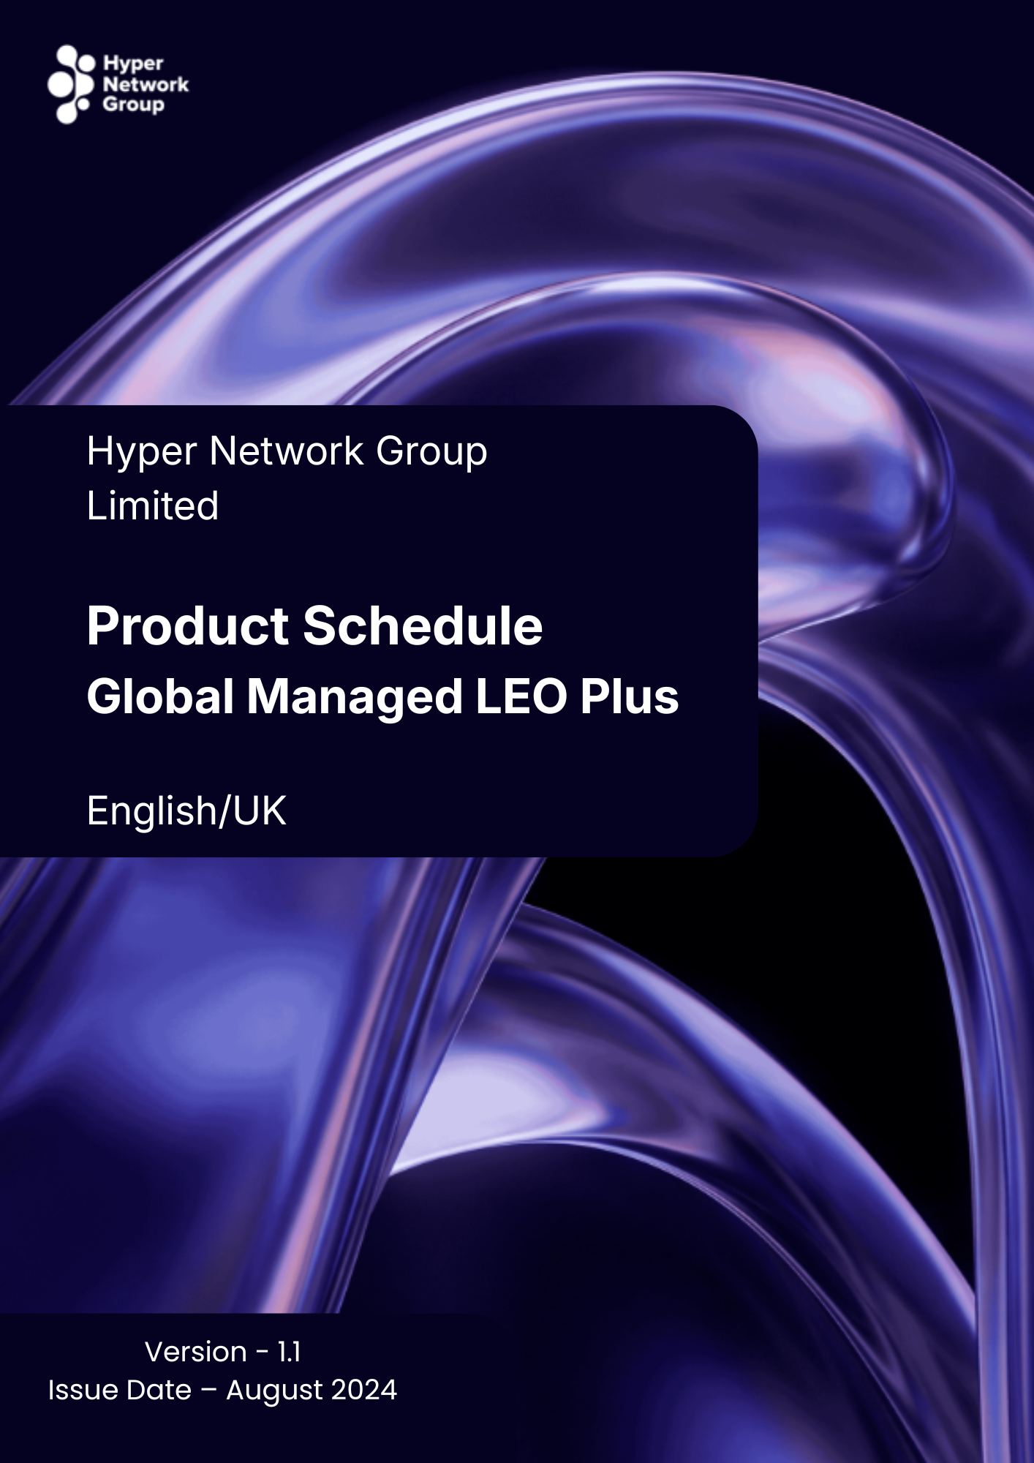

Contents
Hyper Network Group Product Schedules 3
Ordering Process 4
Global Managed LEO Plus Service Terms 5

Hyper Network Group Product Schedules

Hyper Network Group Limited, a company, duly formed and operating under the laws of England and Wales hereinafter referred to as ‘Hyper Logical’.

The Products that Hyper Logical delivers are subject to and governed by the General Terms as supplemented by the additional terms as set out in the relevant Product Schedules in respect of specific Products that the Customer orders from Hyper Logical from time to time.

By ordering GML Services, the Customer agrees to be bound by the additional terms and conditions set out in this Product Schedule for the use of the relevant GML Services from the relevant Service Start Date(s).

Save as expressly amended in respect of the GML Services set out in this Product Schedule, all other provisions of the General Terms (and any Order form or Tariff Addendums) shall continue in full force and effect without amendment.

Disclaimer of promotional materials
The presentation of Products on Hyper Logical’s website does not constitute a legally binding offer, but a non-binding online catalogue. Hyper Logical’s commitments on the specification and/or quality of Products shall be exclusively as set out in the relevant Agreement between Hyper Logical and the Customer. No public statement, promotion or advertising will constitute any contractual commitment from Hyper Logical in respect of the specification and/or quality of any Product(s).

Unless expressly agreed otherwise in writing, the samples that Hyper Logical provides to the Customer before or on the Agreement entering into force are only illustrative samples for the sole purpose of giving an approximate character of the relevant Product(s). The Agreement is not a sale by sample.

Special Conditions
Hyper Logical may agree that certain special conditions apply to the provision of the GML Services as set out in the Master Agreement Form. Where these special conditions apply, they will take precedence over the terms of this Product Schedule to the extent applicable (in accordance with clause 1.4 (Structure) of the General Terms).

Ordering Process

New Customers
New Customers will be provided with a quote by Hyper Logical’s sales team.
To submit an Order, new Customers will be required to enter into a Master Agreement Form and place an Order as advised by Hyper Logical.

Existing Customers
Where a Customer has a valid Master Agreement Form covering the relevant Product(s) that the Customer wishes to Order, the Customer must place its Order for GML Services through the Platform(s) applicable to such Product(s).

Save to the extent that the Customer is acting as a Reseller, the Customer must not place Orders for Product(s) on behalf of any third parties, including members of the Customer’s Group, as Hyper Logical requires that a valid Master Agreement Form covering the relevant Product(s) is in place with each recipient of any Products. The Customer should discuss any of its Group members’ requirements for Products with the relevant Hyper Logical Account Manager.

By placing an Order, the Customer submits an offer to Hyper Logical to provide the relevant Product(s) to the Customer. Any automated e-mail acknowledgement sent by Hyper Logical confirming receipt of the Customer's Order is not a declaration of acceptance for the purpose of forming a binding commitment on Hyper Logical. An Order will be deemed accepted by Hyper Logical in accordance with clause 3.2 (Orders) of the General Terms. For the avoidance of doubt, Hyper Logical is under no obligation to accept the Order.

Hyper Logical’s acceptance of each Order will be subject to credit checking in accordance with the General Terms.

Global Managed LEO Plus Service Terms

The following terms and definitions apply to the provision of GML Services:
“GML Equipment” means Hardware determined to provide the GML Services by Hyper Logical, include at minimum the following elements:
- Satellite Kit, including dish antenna, router, and cabling.
- Panel Bracket. A suitable bracket for service mounting is selected during the site survey process.
- Power Cabling. Standard satellite cabling of up to 25 meters between power point (provided by Customer) and outdoor unit installation location.
- Router. Suitable router for the ordered service.
“GML Services" means the Global Managed LEO Plus services which consists of broadband Internet access to Customers via a low earth orbit (LEO) satellite connection, and the definition of “Services” in the General Terms shall be deemed to include the GML Services for the purposes of these GML Terms.
“Order Form” means the order form submitted by the Customer for the purchase of the GML Services.
“Service Guide" means the service guide for the GML Services provided by Hyper Logical.
“Hyper Logical” means the Hyper Logical company who the Customer purchases the GML Services from together with its successors in title and permitted assigns from time to time.

GML Services
  - If the GML Services shall be purchased through Hyper Logical and are subject to and governed by the applicable General Terms. The General Terms shall apply alongside these GML Terms as if they were set out within them, including, without limitation, each party’s obligations in respect of confidentiality, data protection and limitations of liability.
  - The GML Services are based on internet access from third party Satellite suppliers, bundled with installation, connectivity, and support services from a Hyper Logical Group Company. GML is delivered as service only, which means that any hardware and software used in the provisioning of the service is owned and operated by the Hyper Logical Group and the Customer can only utilise the service for Internet Access.
  - The Customer will choose the product variant on the Order Form. GML Services chosen from the product variants may have additional terms and conditions which are applicable to their use as set out in section 4 below.

Use of the GML Services
  - In addition to the obligations contained in the General Terms, the Customer shall not resell the GML Services without the express permission of Hyper Logical.
  - Reference to End User includes any End User of the GML Services and the obligations of the Customer and its End Users contained in the General Terms shall be deemed to apply to the use of the GML Services.
  - Hyper Logical reserves the right to update or change the coverage list for the GML Services from time to time and to alter the underlying service component which provides the coverage without notice to the Customer. Coverage does not guarantee availability at a specific location in that country.
  - The Service Guide for the GML Services will apply alongside this Product Schedule.

GML Equipment
  - Title to GML Equipment: Ownership of the GML Equipment remains with the Hyper Logical for the service. Customer must not, and must not allow any person to, remove, relocate, modify, damage, destroy or interfere with any GML Equipment. Customer shall keep the GML Equipment safe and report any damage, fault, loss or theft of the GML Equipment promptly to Hyper Logical.
  - Hyper Logical shall be entitled to enter the Customer’s premises to repair or recover any GML Equipment. Should Hyper Logical be unable to do so due to the Customer’s inaction or fault, the Customer will become liable for the full replacement cost of the GML Equipment on its premises.
  - Return of GML Equipment: After termination, Customer must return GML Equipment to Hyper Logical within 30 calendar days. If in Hyper Logical’s reasonable opinion, the GML Equipment recovered is in a condition materially inferior to that condition it was initially installed at Customer’s premises, save for reasonable wear and tear, Customer will be liable for the full replacement cost of this GML Equipment.
  - Transfer Of GML Equipment: On request, Customer may request to have the title and ownership of equipment transferred at the end of the service commitment term. A one-time transfer fee applies as set forth in the price schedule.

Additional Terms for Myriota Services
  - Additional specific conditions are outlined below for the use of the Myriota elements of the GML Service (the “Myriota Services”), including the equipment for the use of the Myriota Services such as cabling and fixtures suitable for those Myriota Services (the “Myriota Equipment”). Customers agree to incorporate into any agreement with its End Users the relevant terms and compliance obligations included in (a) the Myriota Policies described in this Section 4 and applicable to the territory; and (b) the limited warranty described in Section 5.

Myriota Equipment Installation:
    - Equipment installation where installed by Customer: The Customer and/or the End Users are responsible for installation of the Myriota Equipment in a location that has a clear field of view. Do not install under a radome; doing so may adversely affect terminal performance. The Customer and/or the End Users should maintain a minimum separation distance of 4m (14 ft.) between Myriota Equipment and other co-located antennas. The Customer and/or the End Users are also responsible for installing the Myriota Equipment securely so that equipment will not become dislodged due to weather or other external factors. It is the Customer’s and/or the End Users responsibility to ensure compliance with all applicable building codes, zoning, ordinances, business district rules, conditions, restrictions, lease obligations and landlord/owner approvals and requirements that are applicable to the Myriota Services and the installation of the Myriota Equipment. The Customer and/or the End Users are responsible for obtaining any permits and other authorisations necessary for the Services and the installation of the Myriota Equipment. Should use of the Services require any construction or alteration to property, Hyper Logical is not obliged to reimburse any expenses or restore property to the same physical state as prior to delivery of the Myriota Services. If Customer and/or the End User requires a permanent roof mount installation, they acknowledge the potential risks associated with this type of installation, including, without limitation, with respect to any warranty that applies to penetration of any vehicle/vessel roof, building roof or roof membrane.

    - Equipment installation where installed by Hyper Logical Group: If agreed with Hyper Logical, the Customer may receive a range of one-time services from the Hyper Logical Group which includes a site survey and assessment by qualified engineer of the Customer’s installation requirements. The site survey will determine the feasibility of delivering the ordered service and define placement of service equipment. Upon completion of the site survey, the Hyper Logical Group will provide a report with details of the construction requirements and necessary information for Customers, including installation requirements and how to obtain construction approvals. The above requirements in (i) for installation shall apply to this option as if it was installed by the Customer and/or End User, and for the avoidance of doubt obtaining any permits or approvals from building management for placement of service equipment or any construction work is the responsibility of the Customer. If Hyper Logical agrees to provide installation services, this will be subject to further terms and conditions for such installation as provided by Hyper Logical.
  - Myriota Policies. The Customer agrees not to use, or permit others to use including End Users, the Myriota Services in ways that (a) violate any law or applicable regulation, (b) violate the Acceptable Use Policy, or other policies available at https://www.Myriota.com/legal, (c) infringe the rights of others, (d) interfere with the Myriota Equipment, the Myriota network or other networks, or (e) are outside the scope of the Services agreed with Hyper Logical.
  - Use of Myriota Services in-motion: Authorisation is required to use the Myriota Services and Myriota Equipment in-motion within the territorial waters, airspace or on land for certain jurisdictions. The Customer acknowledges and agrees that it and/or End Users are responsible for (a) understanding and complying with all applicable laws and regulations associated with the use of the Myriota Services and Myriota Equipment in-motion, (b) obtaining any required authorisations, where necessary, and (c) ceasing use of the Myriota Services or Myriota Equipment where necessary based on the Myriota Equipment’s geographical location.
  - Security Measures: The Customer acknowledges and agrees that Myriota may administer and enforce cybersecurity policies and procedures to identify and respond to incidents involving Myriota data, mitigate the effects of any such incidents, document their outcomes, and notify appropriate stakeholders (including authorities and affected data subjects, as appropriate).
  - Intellectual Property: The Customer acknowledges and agrees that the name “Myriota” as well as all related marks, logos, and designs are service marks, trademarks, and trade names of Myriota (the “Myriota Trademarks”). The Customer and any End User(s) are not authorised to use the Myriota Trademarks or make any reference to SpaceX in the use of the Myriota Services. Software copies and updates installed on the Myriota Equipment are not sold, only licensed to the Customer and the End Users (on a non-exclusive, non-transferable, limited and revocable basis), for use as installed on the Myriota Equipment and subject to the Software License and Usage Terms (available at https://www.Myriota.com/legal). Myriota reserves all intellectual property rights and other rights and interests in the Myriota Equipment, the Services, and the software, and grants no license, except as expressly granted in these GML Terms.

Limited Warranty
  - The GML Services include new technology that is still being developed and as such Customer acknowledges that service specifications may be amended from time-to-time based on experience and innovation.

  - Myriota Limited Warranty: The Myriota Equipment and Services are novel, under development, and subject to change. Hyper Logical (as permitted by Myriota) will use reasonable efforts to facilitate that the Myriota Equipment, at the time of delivery, and the Myriota Services, as performed, substantially meet performance goals set forth in any specifications that may be provided by Hyper Logical to the Customer in respect of the Myriota Services and as may be amended from time-to-time based on experience and innovation. This Myriota Limited Warranty is provided solely to Hyper Logical. All attempts to exercise the rights granted under the Limited Warranty must be completed by Hyper Logical and not the Customer or End Users.
  - Hyper Logical is not responsible for damage to the Myriota Equipment after delivery, or for Myriota Service malfunctions resulting from: (a) manual re-pointing of the antenna; (b) repair, modification, or disassembly of Myriota Equipment by anyone other than Hyper Logical or its authorised agent; (c) failure to follow instructions, including by obstructing the Myriota Equipment’s field of view; (d) fire, flood, wind, lightning, earthquake, weather, or other acts of nature or God; (e) spills of food or liquids on Myriota Equipment; (f) planned or emergency maintenance on the network; (g) problems with electrical power or network equipment; (h) misuse, abuse, accident, vandalism, alteration, or neglect; (i) normal wear and tear or deterioration, or superficial defects, dents, or marks that do not impact performance of the Myriota Equipment; (j) use in combination with devices or software not provided or approved by Hyper Logical; (k) inability to obtain or maintain necessary permissions, authorisations, or permits; or (l) events not reasonably within Hyper Logical’s control.
  - Except as set forth in this section 5, Hyper Logical provides the GML Services “as is,” without any express warranty or representation. Hyper Logical disclaims all implied warranties and representations, including any implied warranty of merchantability, fitness for particular purpose, and non-infringement.

Charges for the GML Services
  - The definition of “Charges” in the General Terms shall include the amounts payable for the GML Services.
  - The Charges for the GML Services will be set out in the Customer’s Order form.
  - The Customer shall pay the cost of delivering the GML Equipment to the Delivery Address as agreed in the order form (where applicable).

